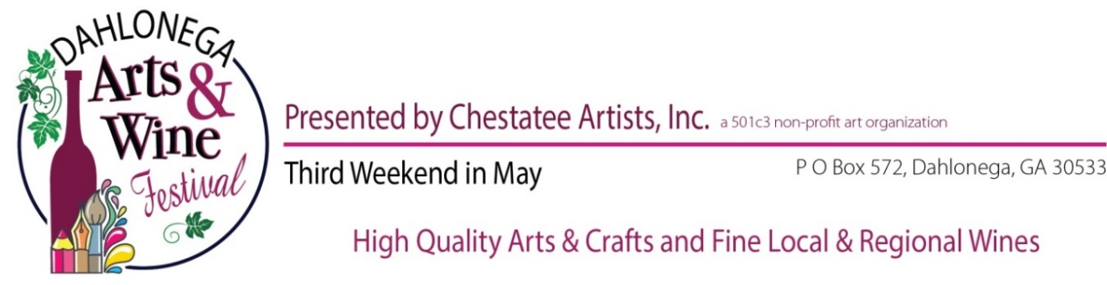
May 20 & 21, 2023
Deadline for Sponsor Levels – January 18, 2023

$3000 Platinum Event Sponsor: Logo at top of Sponsor Banner in Information Tent; Posters; Festival T-Shirt back; Chestatee Artists Web page for Sponsors with logo linked; DAWF Facebook page -frequent postings with link; Booth space (10 x 20 or larger based on business); two Festival T-Shirts; Festival program full page ad

$2000 Gold Sponsor: Logo on Sponsor Banner in Information Tent (below Platinum); Festival T-Shirt back; Posters; Chestatee Artists Web Page for Sponsors with Logo Linked; DAWF Facebook frequent postings with link; Booth space (10 x 20); two Festival T-Shirts; Festival program ad– 1/2 page

$1000 Silver Sponsor: Logo on Sponsor Banner Information Tent (Below Gold); Festival T-Shirt backs; Posters; Chestatee Artists’ Web Page for Sponsors with Logo Linked; DAWF Facebook postings with link; Booth Space (10 x 10); Festival program ad – 1/3 page

Deadline for Sponsor Levels – March 8, 2023
$750 Art Angel: Logo on Sponsor’s Banner in Information booth below Silver level; DAWF Facebook page postings (at least 3); Chestatee Artists’ Web Sponsor Page with link to business; Logo in festival program.

$500 Art Patron: Logo on Sponsor Banner below Art Angel level; Logo in festival program on Sponsor Page; DAWF Facebook page postings (at least 2); Chestatee Artists’ Web Sponsor page with link to business below Art Angel.

$250 Art Education Partner: Logo in festival program; DAWF Facebook page posting (at least 2); Logo on Sponsor Banner in Information booth below Art Patron; Chestatee Artists’ Sponsor Page with link (Funds at this level will be designated specifically for ART EDUCATION locally.)

$100 Friend of the Festival: Name & location in festival program; Name on Sponsor Banner; 1 posting on DAWF Facebook page
Contact Name: _________________________________________________________________
Business or Individual: __________________________________________________________
Sponsor Level: _________________________________________________________________
Address: _______________________________________________________________________
Phone: __________________________ Email: _______________________________________
Festival Director : Letty Rayneri, cell 229-291-3623 or lrayneri@windstream.net
Checks payable to: Chestatee Artists Mail to: P O Box 572, Dahlonega, GA 30533

